**National University of Computer & Emerging Sciences, Karachi**

**FAST School of Computing**

**Fall-2022**

# CS1002–Programming Fundamentals

**Assignment # 1**

**MaxPoints:** 80

**Due Date:** Sunday, Sep 19, 2022, 04:00p.m.

**Carefully read the following instructions!**

## It should be clear that your assignment would not get any credit if the assignment is submitted after the due date.

* Strict actions will be taken if submitted solution is copied from any other student.
* For any query, feel free to email at: **shahbaz.siddiqui**[**@nu.edu.pk**](mailto:mshahzad@nu.edu.pk)
* If you find any confusion in assignment (Question statement), please consult before the deadline. After the deadline no queries will be entertained in this regard.
* **Submission:** Submission will only be accepted in the form of handwritten solution.



**Problem-1**

Write an algorithm and draw flowchart a problem which takes an integer from the user and prints its factors series and also the sum of that series.

**Sample Input: 10**

**Sample Output:**

**Factors of 10 are: 1, 2, 5, 10**

**Sum of series is: 18**

**Problem-2**

An integer is said to be perfect if its aliquot sum equals the number itself. An aliquot sum is the total of a number's appropriate divisors other than itself. For instance, the perfect number is 6, which has the divisors 1, 2, and 3. The total of the aliquots is 1 + 2 + 3 = 6.

Write an algorithm in which user takes an integer and checks whether this number is perfect or not and displays the message accordingly.

**Sample run:**

**Enter a number**

**5**

**“5 is not a perfect number.”**

**Enter a number**

**6**

**“6 is a perfect number”.**

**Problem3:**

Hamid is a mathematician and discovered a number which have unique properties. As he is not decided any name to that number, so for the time being we call that number ‘Cuboid’. A unique property of Cuboid is that, if we break that number into individual units like breaking 124 into 1, 2 and 4 and take their individual cube, then the sum would be the same as original number being given. Write the Algorithm of the given task

**Sample input**

**153**

**Sample Output:**

**The number is Cuboid**

**Problem-4**

A steel company hires you to find their product efficiency. They have set certain conditions on which you have to define a Grade. A certain grade of steel is graded according to the following conditions:

(i) Hardness must be greater than 50

(ii) Carbon content must be less than 0.7

(iii) Tensile strength must be greater than 5600

The grades are as follows:

Grade is A if all three conditions are met

Grade is A- if conditions (i) and (ii) are met

Grade is B if conditions (ii) and (iii) are met

Grade is B- if conditions (i) and (iii) are met

Grade is C if only one condition is met

Grade is C- if none of the conditions are met

Draw a Problem Analysis Chart (PAC) and flowchart, which will ask the user to provide hardness, carbon content and tensile strength of the steel under consideration and then display the grade of the steel.

**Sample input:**

**Hardness is: 60**

**Carbon content is: 0.9**

**Tensile strength is: 6000**

**Sample output:**

**Grade is B**

**Problem: 5**

Ali goes to market for buying milk and fruits. He is having a currency of Rs.5000 with him for marketing. From a shop, he purchases 2.0 kg milk priced Rs.120.0 per kg, 2.5 kg Mango priced Rs.55.0 per kg, 3.5 kg peach priced Rs.100.0 per kg, and 1.0 kg Tomato priced Rs.75 per kg. He gives the currency of Rs.5000 to the shopkeeper. Find out the amount shopkeeper will return to Ali and also tell the total item purchased by drawing the appropriate flowchart.

**Problem: 6**

Draw a flowchart in which a calculator gets as an input x and output three values x3, cos x, and 1/x. It keeps on going until the input value of x is equal to 999, when the program terminates.

**Problem: 7**

Provide a PAC of a system that reads temperature in Centigrade and display a suitable message according to temperature state below:

* Temp < 0 then Freezing weather
* Temp 0-10 then Very Cold weather
* Temp 10-20 then Cold weather
* Temp 20-30 then Normal in Temp
* Temp 30-40 then It’s Hot
* Temp >=40 then Its Very Hot

**Problem: 8**

Draw a flowchart of the following pseudocode:

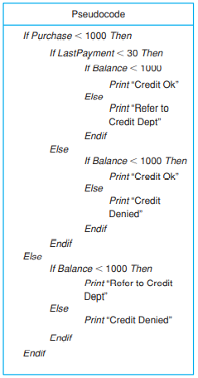

**Problem: 9** (Convert the below flow chart into Algorithm/Pseudocode)

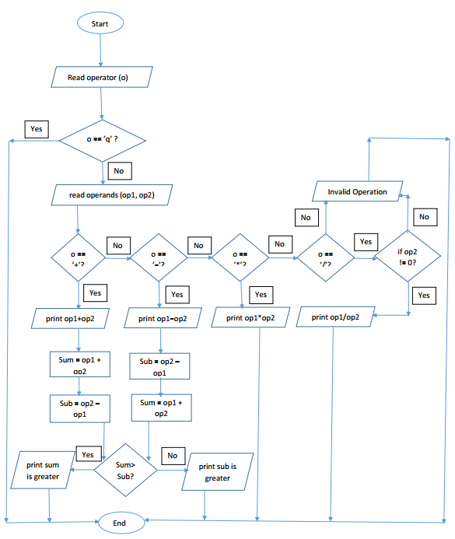

**Problem 10:**

Consider a problem of find the average miles per gallon on a car after six fillups at a gas station. Additional data kept included the number of gallons of gas at each fillup, the starting odometer reading, and the odometer reading at each fillup.

In this problem, which loop did you use? Justify why you used that particular loop. Did you need all of the data that was collected? Why or why not?

### XXXXXGood LuckXXXXX